Module 7: Kubernetes
Assignment – 2

Tasks To Be Performed:
1. Use the previous deployment
2. Create a service of type NodePort for NGINX deployment
3. Check the NodePort service on a browser to verify

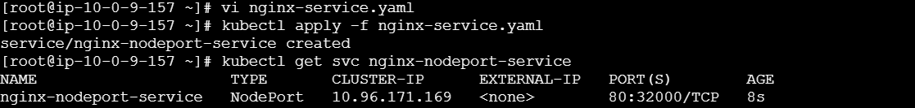
[root@ip-10-0-9-157 ~]# cat nginx-service.yaml
apiVersion: v1
kind: Service
metadata:
name: nginx-nodeport-service
spec:
type: NodePort
selector:
app: nginx # Matches the label defined in your previous deployment
ports:
- port: 80 # The port the service exposes internally inside the cluster
targetPort: 80 # The port the Nginx container is listening on
nodePort: 32000 # Task 2: Explicitly binds port 32000 on your EC2 host instances
[root@ip-10-0-9-157 ~]#

